

**QGIS Lab Series**

**GST 101: Introduction to Geospatial Technology**

**Lab 4: Displaying Geospatial Data**

**Objective – Explore and Understand How to Display Geospatial Data**

**Document Version:** **2014-06-05 (Final)**

**Author:**

Kurt Menke, GISP



**Contents**

1 Introduction 2

2 Objective: Create a Map that Meets the Customer’s Requirements 2

3 How Best to Use Video Walk Through with this Lab 3

Task 1 Add Data, Organize Map Layers and Set Coordinate Reference System 3

Task 2 Style Data Layers 13

Task 3 Compose Map Deliverable 23

5 Conclusion 29

6 Discussion Questions 29

7 Challenge Assignment 30

1. Introduction

In this lab, students will learn how to complete a well-designed map showing the relationship between species habitat and federal land ownership. The student will learn how to style GIS data layers in QGIS Desktop. They will then learn how to use the QGIS Print Composer to design a well crafted map deliverable. The final map will include standard map elements such as the title and map legend.

This lab will also continue to introduce students to the QGIS interface, as QGIS Desktop will be used throughout the course. It is important to learn the concepts in this lab as future labs will require the skills covered in this lab.

This lab includes the following tasks:

* Task 1 – Add data, organize map layers and set map projections.
* Task 2 – Style data layers.
* Task 3 – Compose map deliverable.

1. Objective: Create a Map that Meets the Customer’s Requirements

Often times, you will be provided with a map requirements document from a coworker or customer. For this lab, the student will respond to a map requirements document from a customer who is writing a paper about the state of Greater sage-grouse habitat in the western United States. The map requirements from the customer are below.

Map Requirements from Customer:

Hi, my name is Steve Darwin. I am a wildlife biologist writing a paper on the state of Greater sage-grouse (**Figure 1**) populations in the western United States. I need a letter sized, color, map figure that shows the relationship between current occupied Greater sage-grouse habitat and federal land ownership. I am interested in seeing how much habitat is under federal versus non-federal ownership.

I have been provided data from the US Fish and Wildlife Service depicted current occupied range for Greater sage-grouse. I also have federal land ownership, state boundaries and country boundaries from the US National Atlas. The land ownership data has an attribute column describing which federal agency manages the land (AGBUR).

I want to have the habitat data shown so that the federal land ownership data is visible beneath. I would like each different type of federal land styled with standard Bureau of Land Management colors. The map should also include a title (“Greater sage-grouse Current Distribution”), a legend, data sources and the date. The map should be a high-resolution (300 dpi) jpg image.

I trust that you will get the figure right the first time, so please just submit the completed figures to the managing editor directly.

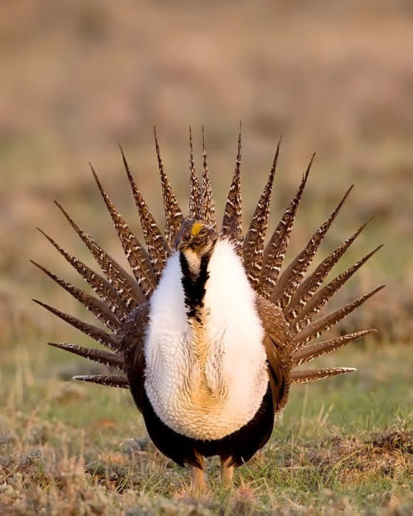

**Figure 1: Male Greater sage-grouse**

1. How Best to Use Video Walk Through with this Lab

To aid in your completion of this lab, each lab task has an associated video that demonstrates how to complete the task. The intent of these videos is to help you move forward if you become stuck on a step in a task, or you wish to visually see every step required to complete the tasks.

We recommend that you do not watch the videos before you attempt the tasks. The reasoning for this is that while you are learning the software and searching for buttons, menus, etc…, you will better remember where these items are and, perhaps, discover other features along the way. With that being said, please use the videos in the way that will best facilitate your learning and successful completion of this lab.

1. Add Data, Organize Map Layers and Set Coordinate Reference System

In this first task you will learn a new way to add data to QGIS Desktop. You will then set the projection for the map project, organize the data layers in the Table of Contents and change the layer names.

1. The data for this lab is located at C:\GST101\Lab 4 on the lab machine. Copy this data to a new working directory of your choosing.
2. **Open QGIS Desktop 2.2.0.**

In Lab 2 you learned how to add data to QGIS Desktop by using the Add Vector Data and Add Raster Data buttons. Now you’ll learn another method of adding data to QGIS Desktop. You’ll use the QGIS Desktop Browser tab.

1. **Select** the **Browser** tab at the bottom of the Table of Contents (**Figure 1**).

NOTE: If the Browser tab is not there **right click** on the blank space to the right of the Help menu. This opens a context menu showing all the toolbars and windows that can be added to the QGIS Desktop interface. **Check** the box next to **Browser**. The Browser tab is added to the Table of Contents .

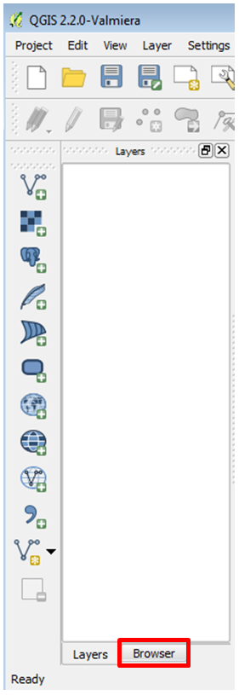

**Figure 1: QGIS Browser Tab in QGIS Desktop**

1. Using the file tree in the Browser window **navigate** to the **Lab 4 data** folder.
2. **Right click** on the Lab 4 data folder and choose **Add as a favourite** from the context menu.
3. When recent changes have been made, such as setting a folder as a favourite, the Refresh button needs to be used in order to see the changes. **Click** the **Refresh** button (**Figure 2**).

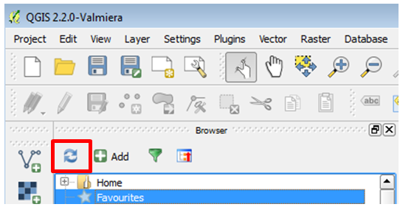

**Figure 2: Refresh button in the QGIS Desktop Browser window**

1. Now expand **Favourites** near the top of the file tree in the Browser window by **clicking** the **plus sign** to the left**.** You will see the Lab 4 data folder listed. Setting the folder as a favourite allows you to quickly navigate to your working folder.
2. You will see 5 shapefiles in the lab data folder:

* Canada.shp
* Land_ownership.shp
* Mexico.shp
* Sage_grouse_current_distribution.shp
* Western_states.shp

1. You can select them all by holding down the **Ctrl** key on your keyboard while left clicking on each shapefile. **Select** the five shapefiles **(Figure 3)**.

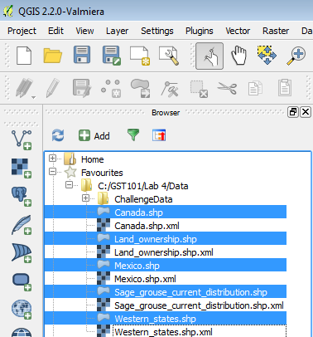

**Figure 3: Shapefiles selected in Browser window**

1. You can select them all by holding down the **Ctrl** key on your keyboard while left clicking on each shapefile. **Select** the five shapefiles **(Figure 3)**.
2. While holding the **Ctrl** key down drag the five selected shapefiles onto the map canvas. This is another way of adding geospatial data to QGIS Desktop. QGIS Desktop should now look like **Figure 4**. The random colors that QGIS assigns to the layers may be different than Figure 4 but that is fine

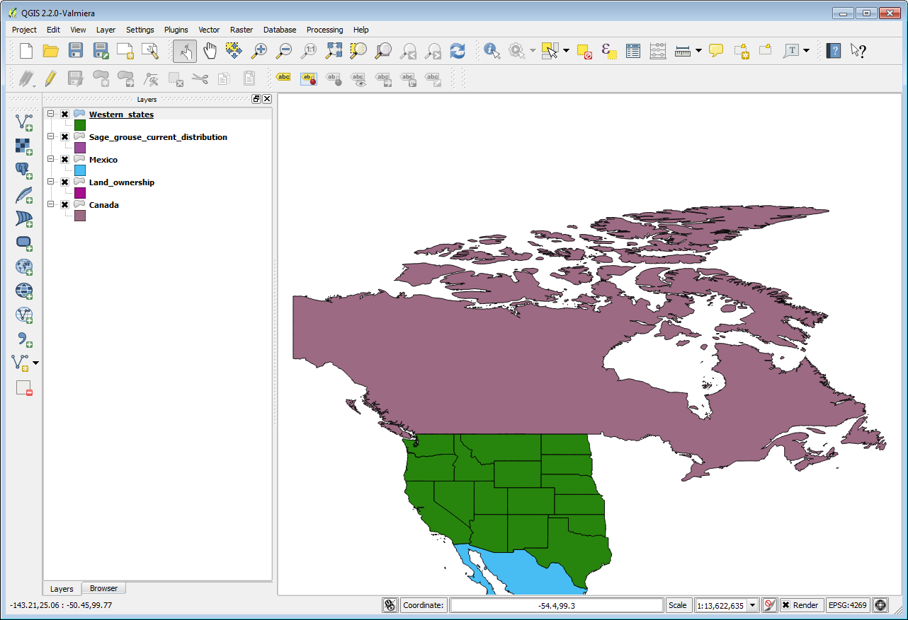

**Figure 4: Shapefiles added to map window**

1. Now **click** on the **Layers** tab on the Table of Contents window to switch to the view of your map layers. (**Figure 5**).

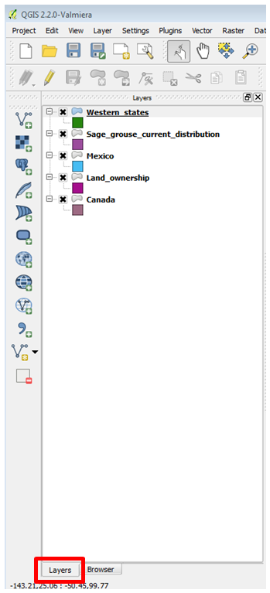

**Figure 5: Layers tab in QGIS Desktop**

1. Save your map. **Click** on **Project 🡪 Save** from the menu bar. Navigate to your Lab 4 folder and save your project as **Lab 4 (Figure 6)**.

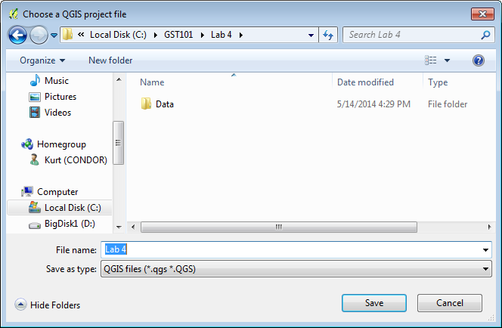

**Figure 6: Saving QGIS Project**

1. We have five layers but currently all we can see are data for Canada, Mexico and the Western states. When you cannot see a dataset one approach is to make sure the spatial extent of your map window covers that dataset. **Right click** on the **Sage_grouse_current_distribution** and choose **Zoom to Layer Extent** from the context menu. This will zoom you into the extent of that dataset.
2. That zooms you into the western United States but you still cannot see anything that looks like habitat data (**Figure 7**).

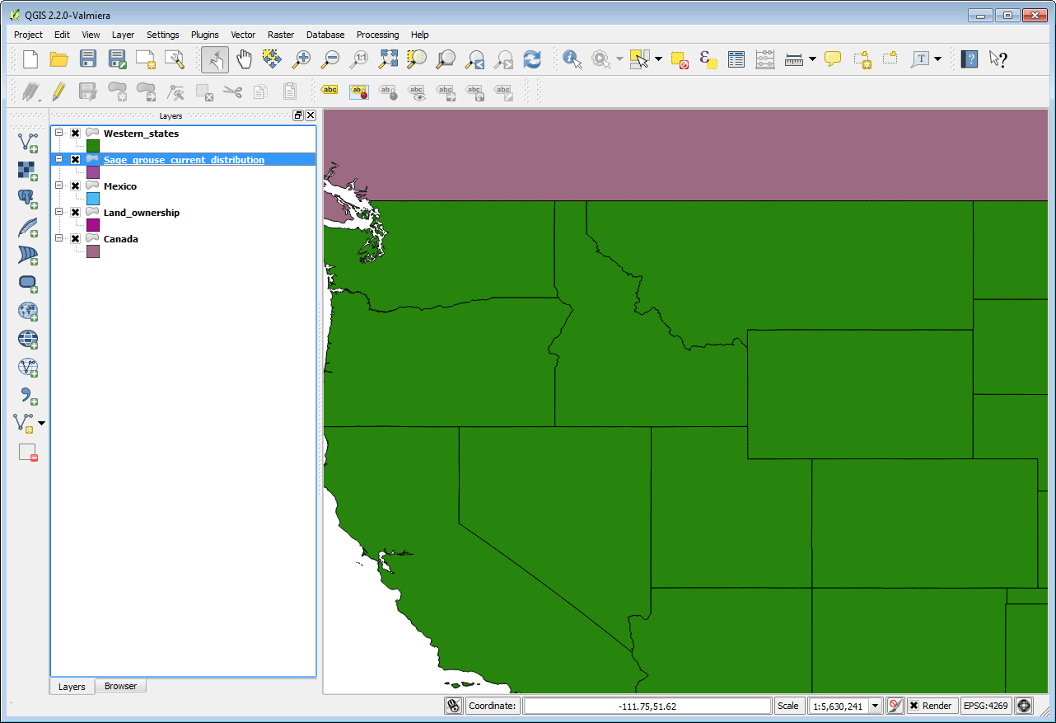

**Figure 7: Zoomed into Sage_grouse_current_distribution**

The data layers in the table of contents are drawn in the order they appear in. So the layer that is on the top of the list in the Table of Contents will be drawn on top of the other layers in the map view. Notice that the Western_states layer is in that top position. This mean that Western_states is covering up the **Sage_grouse_current_distribution** and Land_ownership data.

1. You can change this drawing order. **Select** the **Land_ownership** data layer in the Table of Contents and **drag** it to the top position. You will see a blue line as you drag this layer up the list.
2. Your map should now look like **Figure 8**.

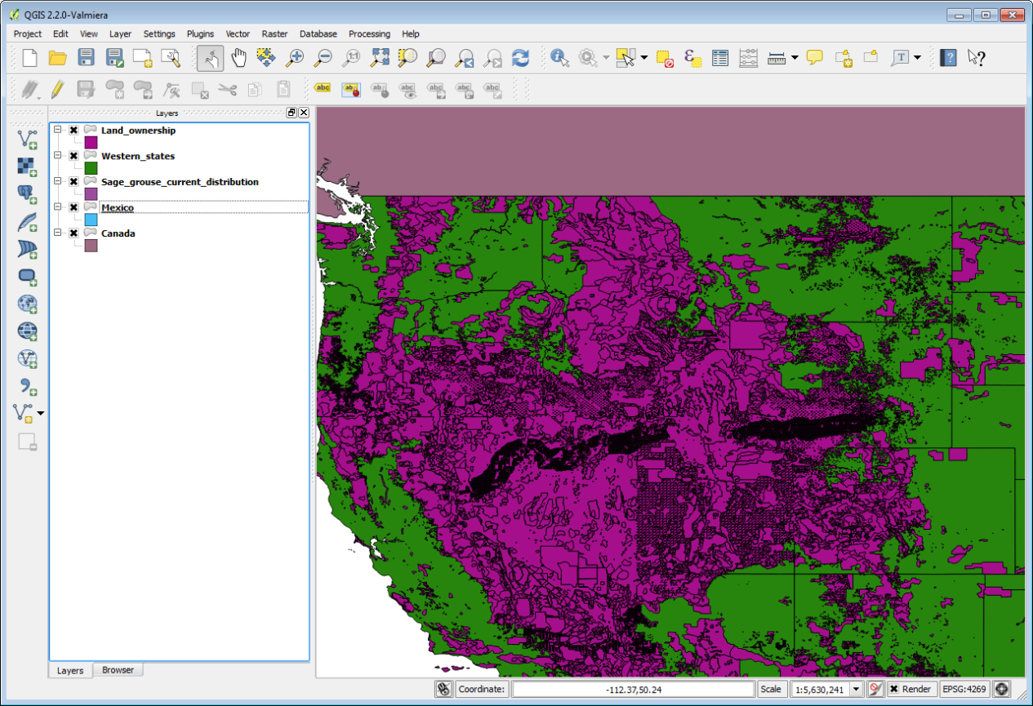

**Figure 8: Land ownership in the top position**

1. Now drag the **Sage_grouse_current_distribution** layer into the top position. Your map should now resemble **Figure 9**. Now all the data layers should be in the correct order. Typically, data layers will be organized with point data layers on top of line layers on top of polygon layers. Raster data layers are usually placed near the bottom. There are always exceptions however.

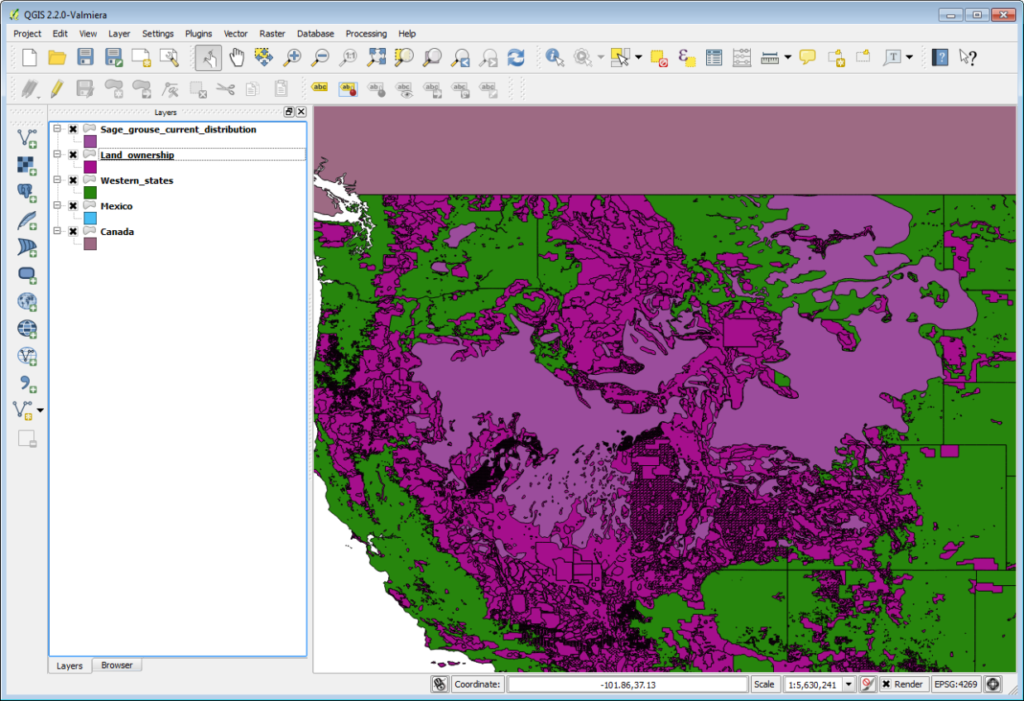

**Figure 9: Land ownership in the top position**

1. Next you will set the coordinate system for the map. Note that the lower left hand corner of QGIS reads **EPSG: 4269**. This is the EPSG code for the coordinate reference system (CRS) the map is currently in (**Figure 10**).

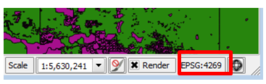

**Figure 10: Map EPSG code**

1. Click on **Project 🡪 Properties** from the menu bar to open the **Project Properties** window. **Select** the **CRS** tab. The current QGIS map CRS is listed at the bottom (**Figure 11**). This is a fuller explanation of the maps CRS which is a geographic coordinate system using the NAD83 datum. This CRS makes the lower 48 look stretched out and distorted so you’ll want to change the maps CRS into something that makes the lower 48 “*look correct*”. Make sure that the **Enable ‘on the fly’ CRS transformation** option is checked. **Click OK** to close the **Project Properties** window.

Since the **Sage_grouse_current_distribution** layer is in an Albers projection, and the QGIS map is in a geographic CRS, that means that the **Sage_grouse_current_distribution** layer, is being projected on the fly into the geographic projection of the map.

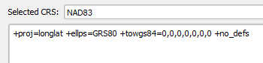

**Figure 11: Map CRS from Project Properties**

1. **Right click** on the **Sage_grouse_current_distribution layer** and choose **Set Project CRS from Layer** option on the context menu (**Figure 12**). This will put the map into the Albers CRS of the Sage grouse layer. Note that the EPSG code in the lower right corner now reads 5070 for the Albers CRS. This CRS gives the western US an appearance we are more used to. Any other map layers not in Albers, will now be projected on the fly into Albers.

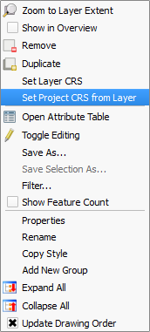

**Figure 12: Map CRS from Project Properties**

1. Now you will change the layer names in the Table of Contents. The layer names match the names of the shapefiles by default. However, these names will appear on the legend. So you will always want to change these to proper names that your map reading audience will understand.  **Right click** on the **Sage_grouse_current_distribution** layer, and choose the **Properties** from the context menu, to open the **Layer Properties** window. Choose the **General** tab on the left. Click in the box next to **Layer name** and change the name to **Sage-grouse Habitat (Figure 13).** **Click** **OK** to close the Layer Properties window.

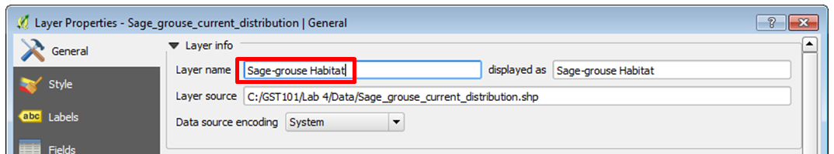

**Figure 13: Changing Layer Name**

1. Change the other layers as follows:

|  |  |
| --- | --- |
| **Current Layer Name** | **New Name** |
| Land_ownership | Federal Land Ownership |
| Western_states | State Boundaries |

1. Click the **Save** button to save the changes you’ve made to your project (**Figure 14**).

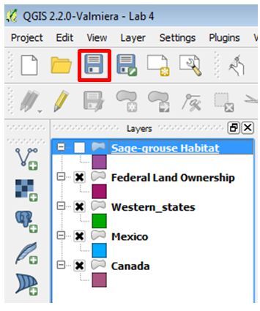

**Figure 14: Save button**

1. Style Data Layers

Now that you’ve set up your map you’ll style your layers and begin to craft a well designed map.

1. Visually you’ll want the land ownership and sage-grouse habitat to have the most weight. Canada and Mexico are there for reference but should fall to the background. You’ll make them both light gray.
2. **Double click** on the **Canada** layer to open the **Layer Properties** window. This is another way to open Layer Properties.
3. **Click** on the **Style** tab.
4. In the **Symbol layers** box click on **Simple fill (Figure 14)**.

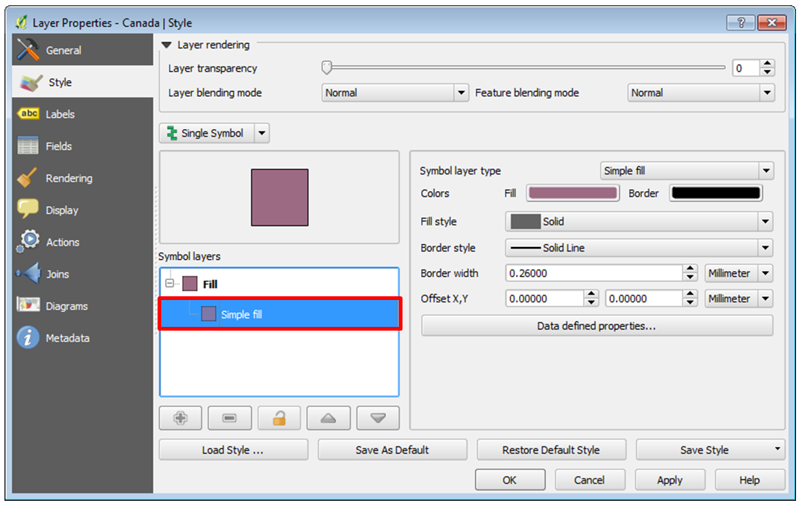

**Figure 14: Layer Style**

1. Find the **Symbol layer type** box on the right side of the window. This allows you to change both the fill and outline symbols for this polygon layer. **Click** on the colored box to the right of **Fill** to open the **Select Color** window.
2. You can pick existing Basic colors or define a color via A) hue, saturation and value (HSV) or B) red blue and green (RGB) values. **Set** the color to **Hue: 0 Sat: 0 and Val: 225.** Make your Select Color window match **Figure 15**. **Click** the **Add to Custom Color**s button to save this color. Click **OK** to close the window.

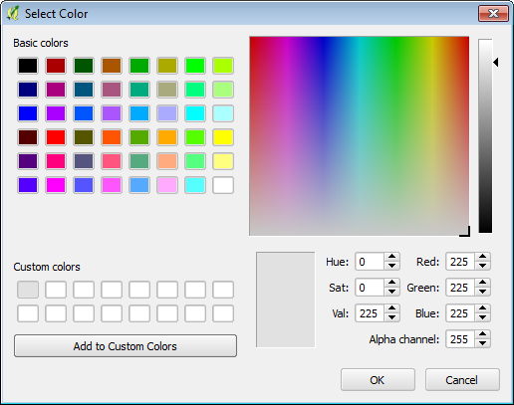

**Figure 15: Select Color**

1. Click **OK** on the **Layer Properties** windowto close and style the Canada layer**.**
2. **Open Layer Properties** for Mexico. Make Mexico the same color as the Canada layer. You can just choose the Custom color you just saved.
3. Your map should now look like **Figure 16.**

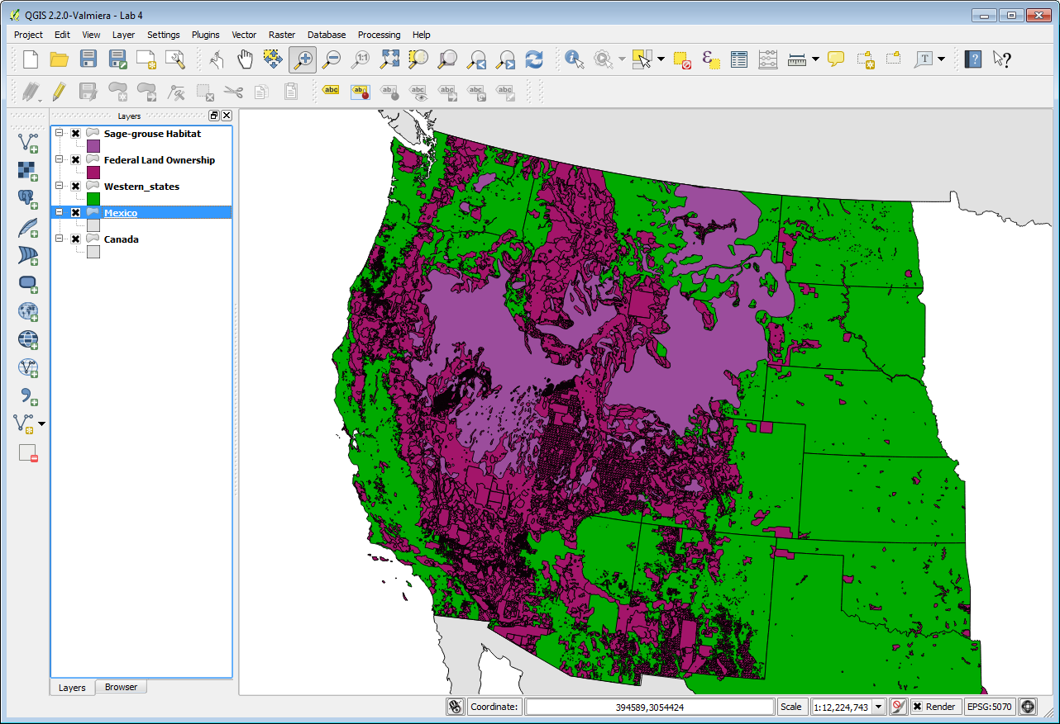

**Figure 16: Mexico and Canada changed to a gray fill**

1. Using the same workflow **give** the **State Boundaries** a **white** fill. You’ll be able to find white in the **Basic colors** palette.
2. Now you’ll style the **Land Ownership** layer. Instead of making the entire layer one color as you’ve done thus far, you’ll assign a unique color to each land managing agency. How do you know who is managing each parcel? This will be information contained in the attribute table. **Right click** on Land Ownership and choose **Open the Attribute Table** from the context menu. There are 13 column of information (**Figure 17**). Can you find the one that contains the land manager?

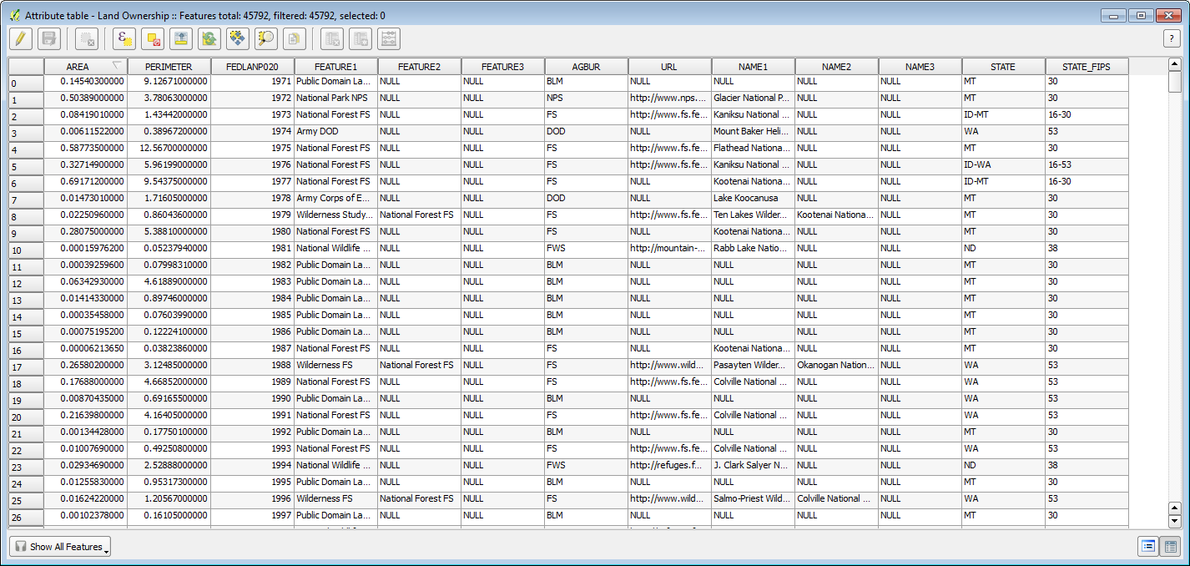

**Figure 17: Land Ownership attribute table**

1. **Open** the **Layer Properties** for **Land Ownership** to the **Style** tab. So far you’ve used the default Single Symbol type. Now you’ll switch to **Categorized**. **Click** the **drop down menu** and change from Single Symbol to **Categorized** (**Figure 18**).

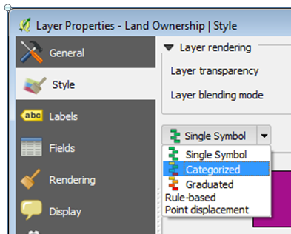

**Figure 18: Categorized symbolization**

1. Now you have the option of choosing an attribute column to symbolize the layer by. The column AGBUR is the one that contains the managing agency values. **Click** the **drop down arrow** and choose **AGBUR** for the **Column**. Then **click** the **Classify** button (**Figure 19**). This tells QGIS to sort through all the records in the table and identify all the unique values. Now you can assign a specific color to each.

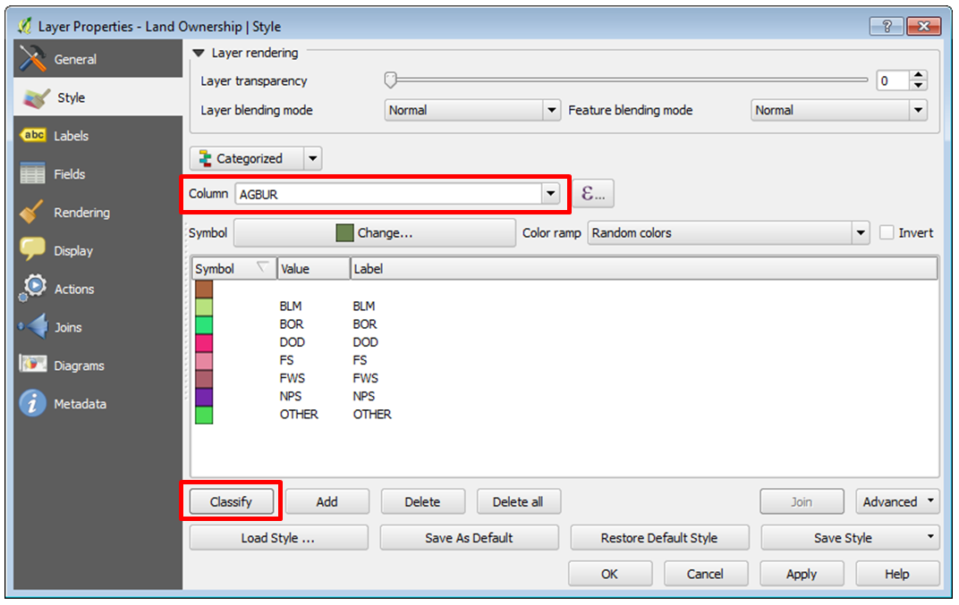

**Figure 19: Categorized symbols by Attribute**

1. Notice that there is a symbol with no values. These are parcels with no values (NULL) in the AGBUR field. They represent private and state inholdings within federal lands. Since you’re just interested in depicting federal land ownership you’ll delete that symbol class. **Select** that top symbol by clicking on it, and then click the **Delete** button below to remove that symbol. Now those parcels will not be included on the map.

For the remaining federal land ownership symbols you’ll use the BLM Standards Manual for land ownership maps (<http://www.blm.gov/noc/st/en/business/mapstandards/colormod.html>). They have designated colors for each type of land ownership. When composing a map it is important to pay attention to industry specific standards. Following them will make the map more intuitive to the target audience. For example, people are used to seeing Forest Service land depicted in a certain shade of green.

1. To color BLM lands double **click** on the **color patch left of BLM** in the Style window. The **Symbol selector** will open. **Click** on **Simple fill**. You won’t want any border lines on these polygons. With such a complicated thematic polygon layer they are too visually distracting. Choose a **Border style** of **No Pen**. Then **click** on the **color patch right of Fill** (**Figure 20**) to open the **Select Color** window.

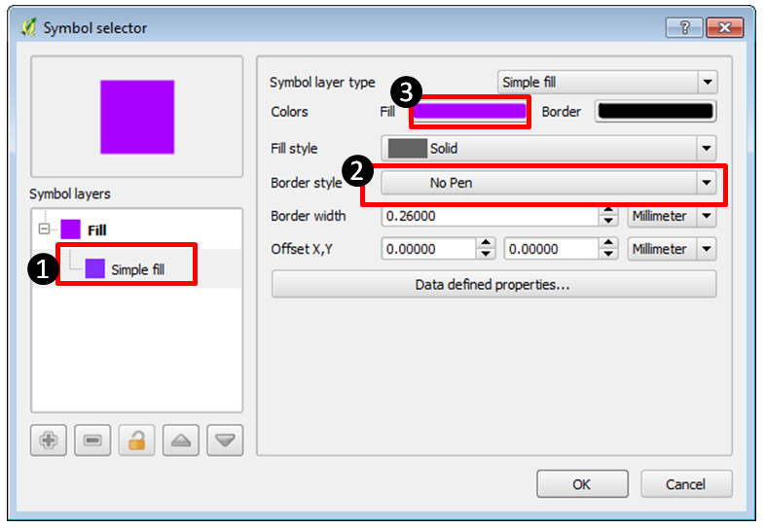

**Figure 20: Symbol Selector for BLM lands**

1. In the **Select Color** window change the Red, Green and Blue values to **254 – 230 – 121** (**Figure 21**). This will change the color to a specific shade of tan representing BLM lands. **Click** **OK** in the **Select Color** window. Then **click** **OK** in the **Symbol Selector** to save the BLM style.

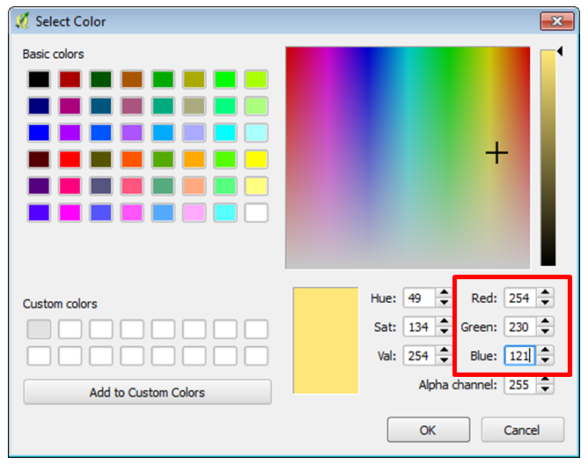

**Figure 21: Select Color for BLM lands**

1. Use the values in Table 1 to change the colors for the remaining six land ownership classes.

|  |  |
| --- | --- |
| **Land Ownership Class** | **Red-Green-Blue Color** |
| BOR | 0-255-255 |
| DOD | 251-180-206 |
| FS | 179-222-105 |
| FWS | 127-204-167 |
| NPS | 177-137-193 |
| OTHER | 150-150-150 |

**Table1: Land Ownership Color Definitions**

1. When finished, **click** **OK** on the **Layer Properties** for Federal Land Ownership. Turn off Sage-grouse Habitat by **clicking** the **X** next to the name in the Table of Contents. Your map should now resemble **Figure 22**.

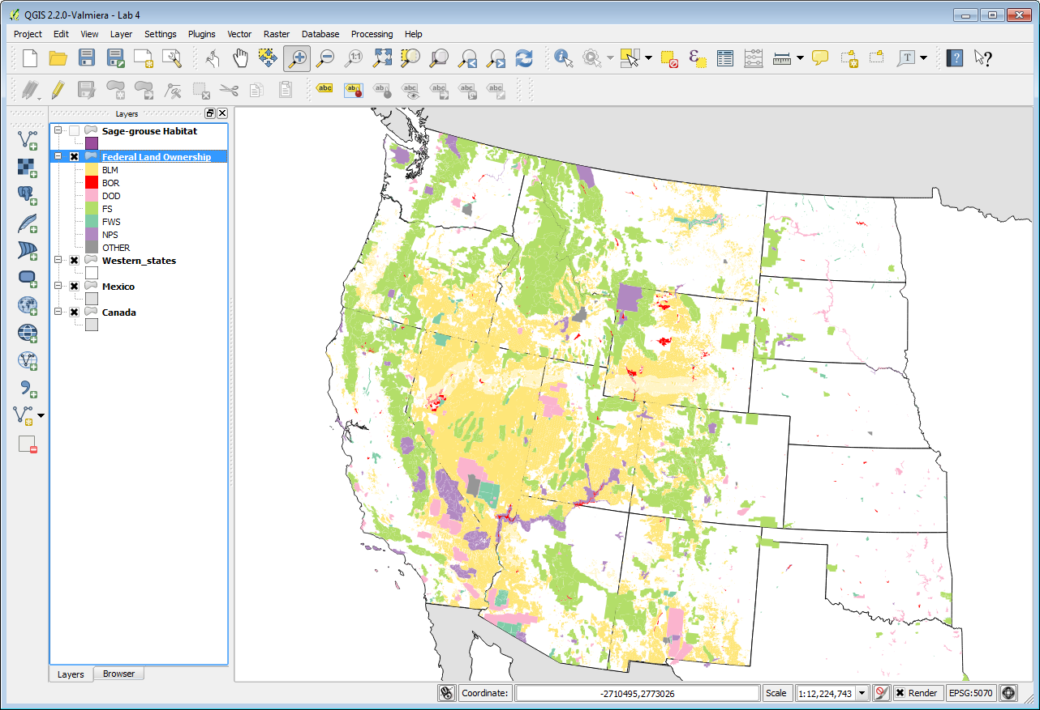

**Figure 22: Styled Federal Land Ownership**

1. Now you’ll set a background color for the map. Since states are filled with white, setting a background color of light blue will serve to represent the Pacific ocean. From the menu bar choose **Project 🡪 Properties**. On the **General** tab **click** the white color patch next to **Background color**. Set the RBG value to: 225-255-255. **Click** **OK** on the **Select Color** window and **OK** on **Project Properties** to save the setting. Depending on your current map extent, the area east of the states layer may be blue now too. That is fine. For the final map we’ll be zoomed in so you won’t see that.
2. The states are white with a black border and serve to show non-federal land as white which is great. However, the state boundaries are obscured since State Boundaries are below Federal Land Ownership. Go to the **Browser tab** and **add Western_states.shp** to the map again. You can have multiple copies of layers for cartographic purposes. **Drag** the Western_states layer **to the top** of the **Table of Contents**. Go into the **Layer Properties 🡪 Style** tab and **click** on **Simple fill**. Give the layer a **Fill style** of **No Brush** (**Figure 23**). It will now just be the state outlines above Federal Land Ownership. **Click** **OK** to save.

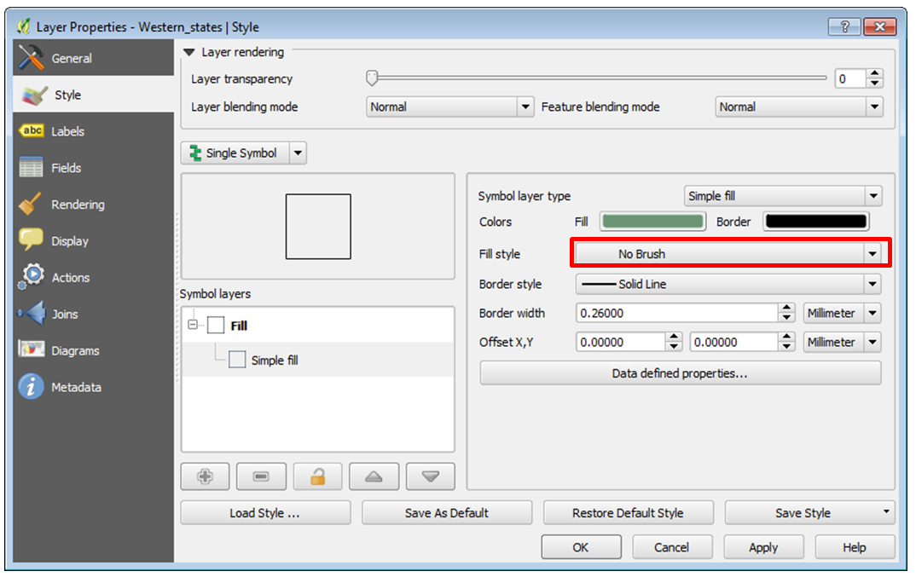

**Figure 23: Giving Western_states a No Brush fill**

1. Your map should now resemble **Figure 24**.

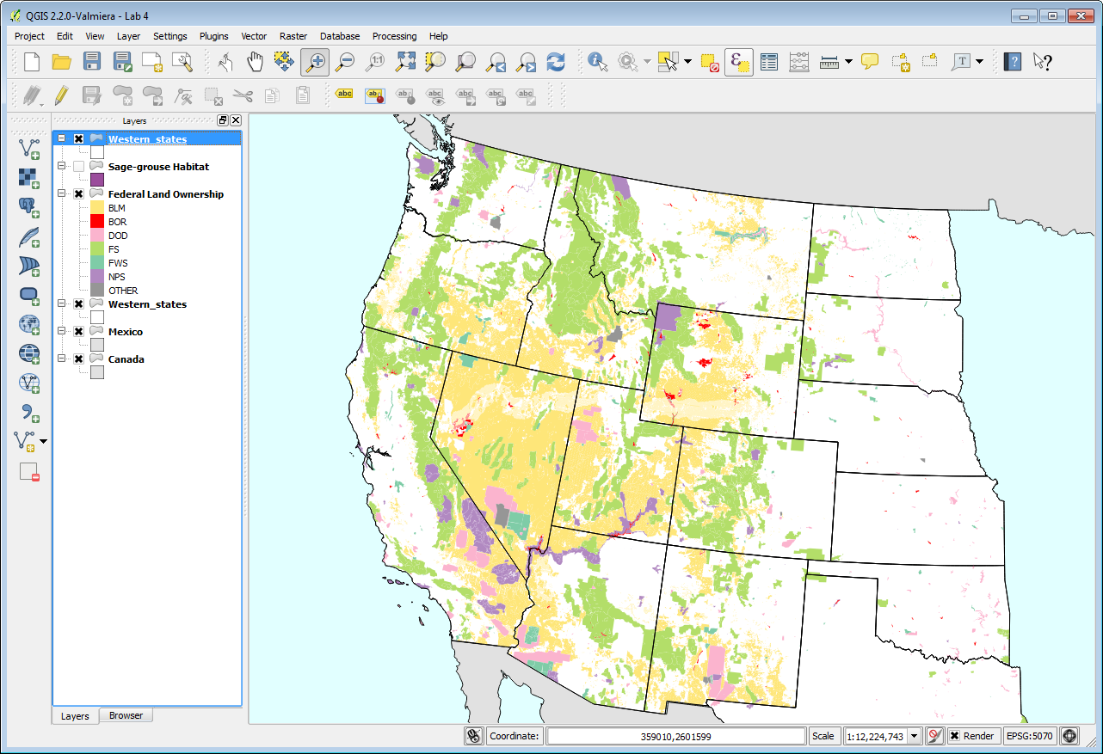

**Figure 24: Hollow states layer added to map**

The last layer to work with is the Sage-grouse Habitat. You’ll make the Sage-grouse Habitat polygons have a cross hatch pattern. This will allow the map reader to see the land ownership data beneath.

1. Open the **Layer Properties** for **Sage-grouse Habitat**. **Click** on **Simple fill**. Change the **Fill** to RGB **170-0-255**. Change the **Border** to RGB **142-0-213**. Make the **Fill style FDiagonal**. Finally change the **Border width** to **0.46** (**Figure 25**). **Click** **OK**. Your map should now resemble **Figure 26**. Save your project!

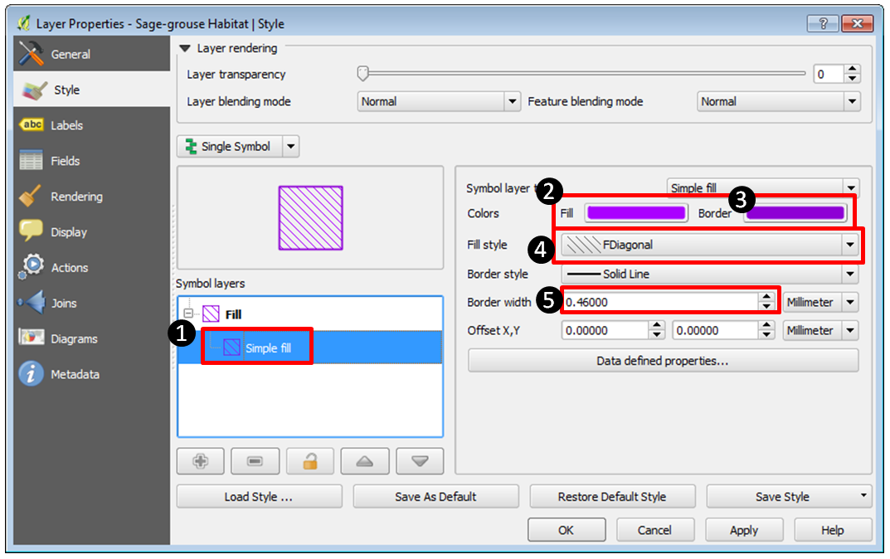

**Figure 25: Sage-grouse Habitat styling**

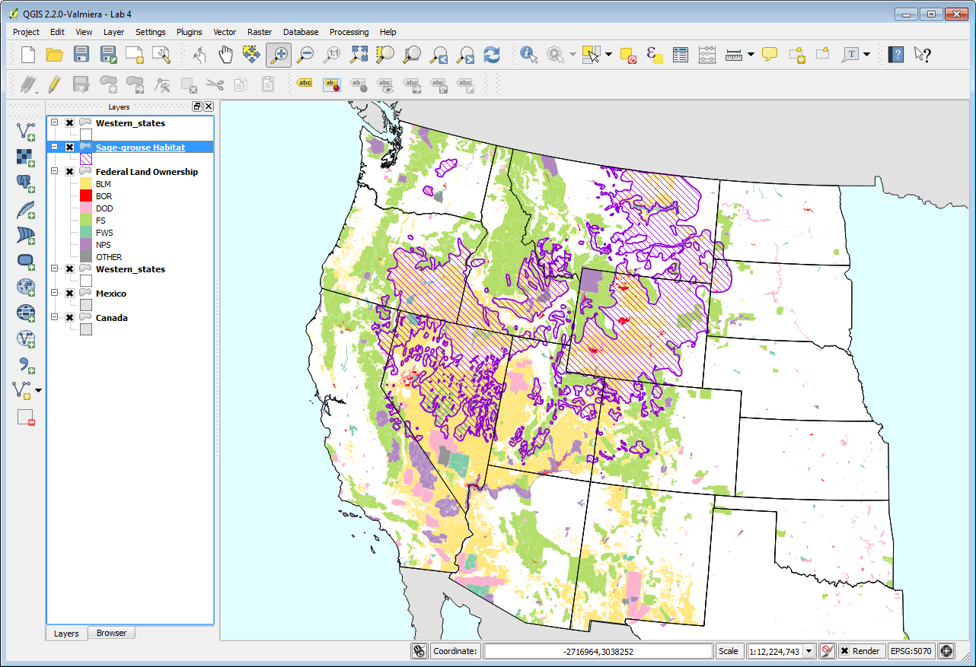

**Figure 26: All layers styled**

1. Compose Map Deliverable

Now that all the data is well styled you can compose the map deliverable.

1. Zoom in tighter to the Sage-grouse Habitat data. Use the Zoom in tool 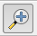and drag a box encapsulating the sage-grouse habitat. Leave a little of the Pacific Ocean visible to the west to give some context (**Figure 27**). As it turns out the data for Mexico is not needed. Sometimes you are given data that doesn’t end up being used.

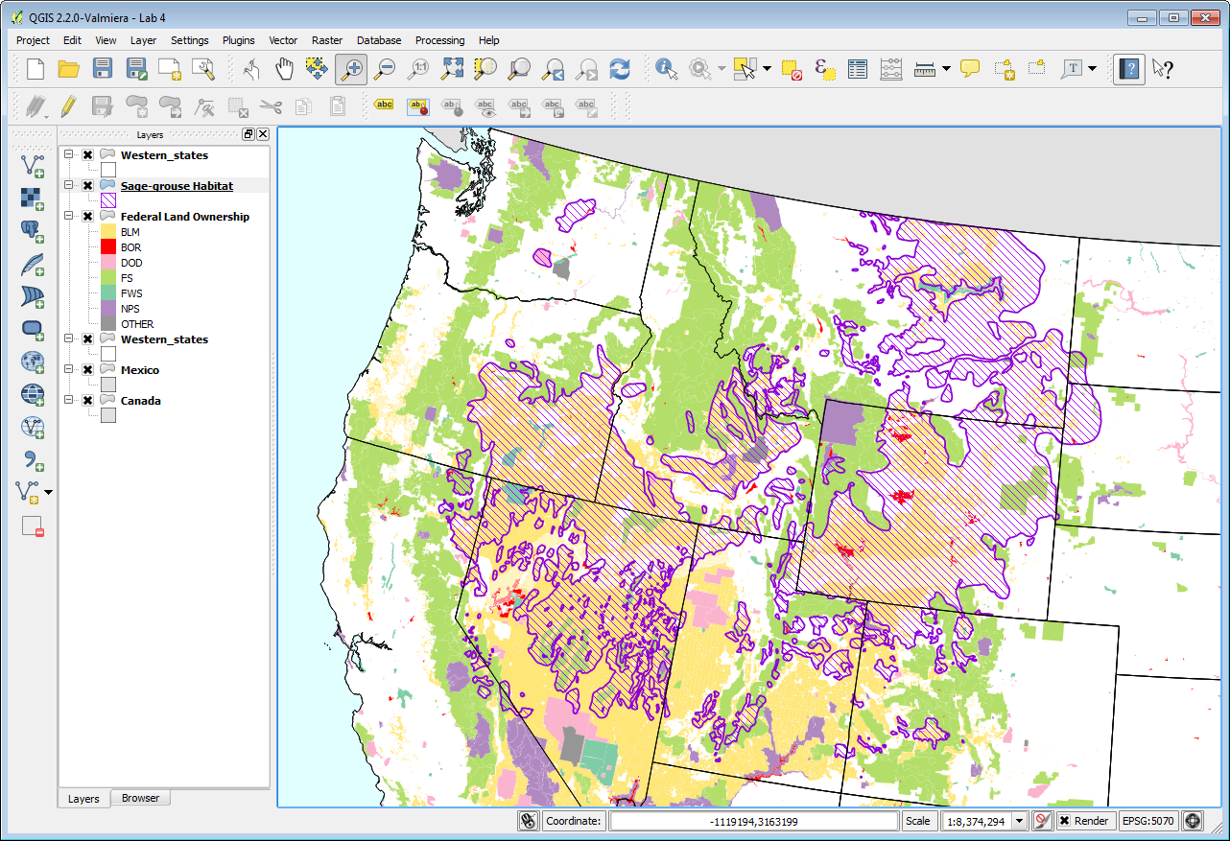

**Figure 27: Final Map Extent**

1. From the menu bar choose **Project 🡪 New Print Composer**. Call the Composer “*Lab 4- Sage-grouse Habitat*” (**Figure 28**). **Click OK**. The Print Composer will open. This is where you craft your map.

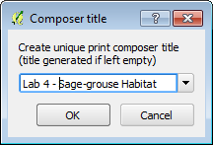

**Figure 28: New Print Composer**

**The Print Composer** is an application window with many tools that allow you to craft a map. You may want to refer to the QGIS manual here: <http://www.qgis.org/en/docs/user_manual/print_composer/print_composer.html> The main window shows the piece of paper upon which the map will be designed. There are buttons along the left side of the window that allow you to add various map elements: map, scalebar, photo, text, shapes, attribute tables etc. Each item added to the map canvas becomes a graphic object that can be further manipulated (if selected) by the **Item Properties** tab on the right side of the composer. Across the top are buttons for exporting the composition, navigating within the composition and some other graphic tools (grouping/ungrouping etc.)

1. On the **Composition tab** you can specify details about the overall composition. Set the **Presets to ANSI A (Letter**). Set the **Orientation to Landscape**. Set the **Export resolution to 300 DPI**. These are listed as map requirements at the beginning of the lab.
2. Using the **Add new map** button  drag a box on the map canvas where you’d like the map to go. Remember that you’ll need room for a title at the top of the page and a legend to the right of the map (**Figure 29**). The map object can be resized after it’s added by selecting it and using the handles around the perimeter to resize.

Map extent helpful hints: Generally, the map will look as it does within QGIS Desktop. However, you may need to change the map extent in **QGIS Desktop**, go back to the **Print Composer**, select the **map object** and go to the **Item Properties** tab and choose **Update Preview**. While there, you can also choose to **Set to Map Canvas Extent**. If the map extent is still not quite right, you can use the **Move Item Content** button on the left side to pan the map contents around within the map object. It is normal to have some back and forth with QGIS Desktop and the Print Composer before getting the map just right.

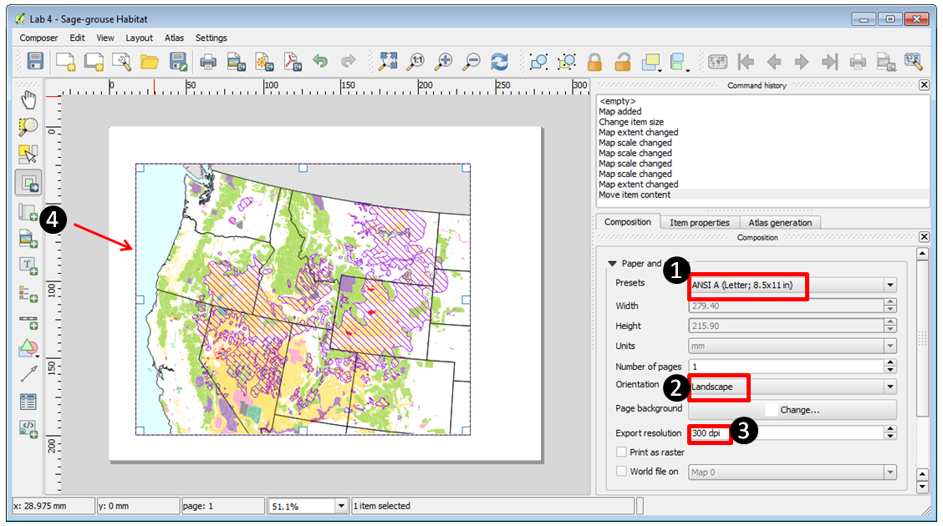

**Figure 29: New Print Composer**

1. Now you will add the Title. Use the **Add new label** tool  to drag a box all the way across the top of the composition. The text box can be resized after the fact by using the graphic handles. Use the **Item Properties** to type in the title. Refer to the map requirements at the beginning of the lab for the exact title wording. **Click** the **Font** button on the **Item Properties** to change the font to: **Times New Roman, Bold, Size 36**. Finally align the title horizontally to the Center (**Figure 30**).

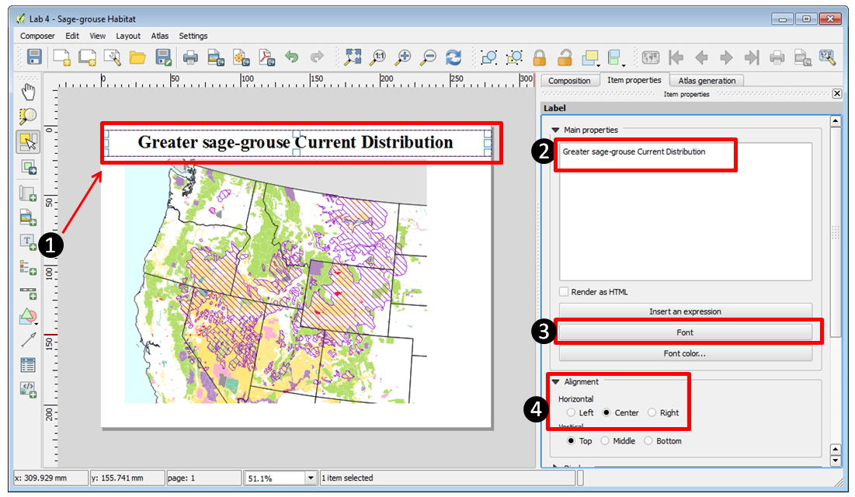

**Figure 30: Adding A Title**

1. Now you’ll add a Legend. Use the **Add new legend** tool 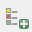 to drag a box on the right side of the map (**Figure 31**).

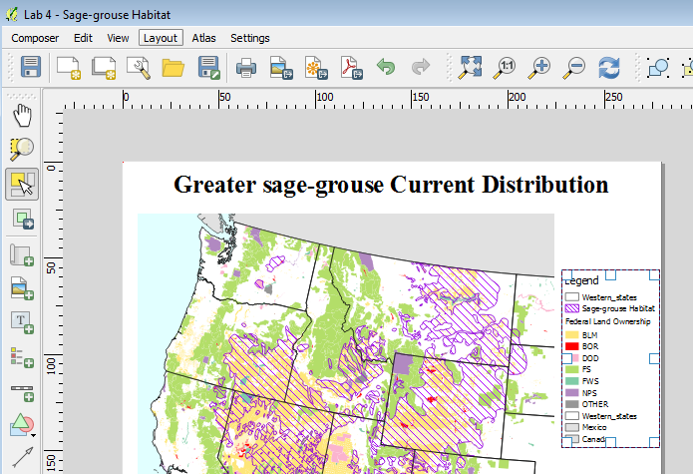

**Figure 31: Adding A Legend**

1. The upper most Western_states layer doesn’t need to appear in the legend, nor does Mexico. Western_states is there purely for cartographic reasons. Mexico doesn’t appear on the map. The **Item Properties** tab will be used to configure the legend (**Figure 32**).

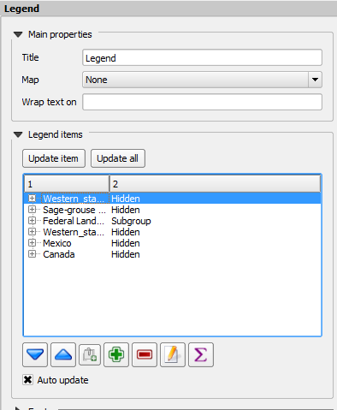

**Figure 32: Legend Properties**

1. **Select** the Western_states layer and **click** the **Delete** item button 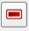 to remove it. Do the same for Mexico.
2. **Expand** the **Federal Land Ownership** layer. Click on the BLM class and click the Edit button 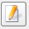. Change the name to “*Bureau of Land Management*”. Go through each remaining land ownership class and edit them to match **Figure 33**.

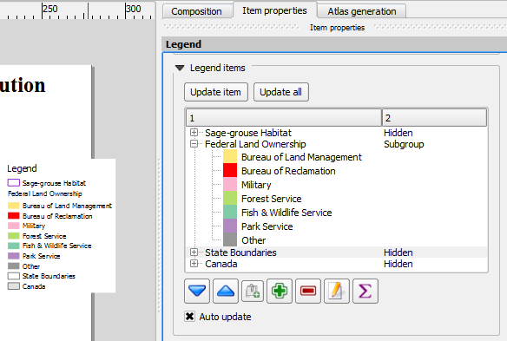

**Figure 33: Legend Layer Labels**

1. Add a neatline. A neatline is a frame around that map. Click the **Add Rectangle** tool (**Figure 34**). **Drag a box** around the map object and legend. On the **Item Properties** tab **click** the **Style Change** button. **Click** **Simple fill** and give it a **Fill style** of **No Brush**. Give it a **Border width** of 1. Adjust the box so that it aligns with the map boundary.

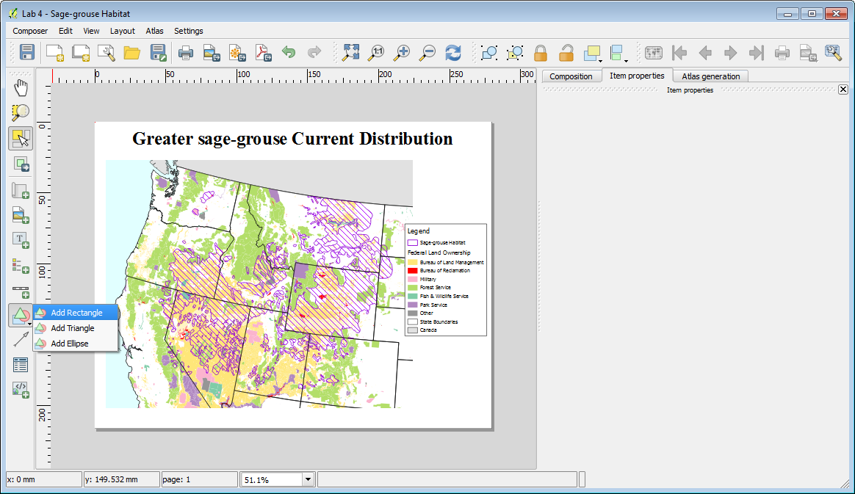

**Figure 34: Adding a Neatline**

1. The last items to add are the data sources and date. Use the Add new label tool click in the lower right hand corner of the composition. Using the Item Properties type:

*Data Sources: The National Atlas & USFWS*

*Date: Month Day, Year*

1. Make the font size 8. (**Figure 35**)

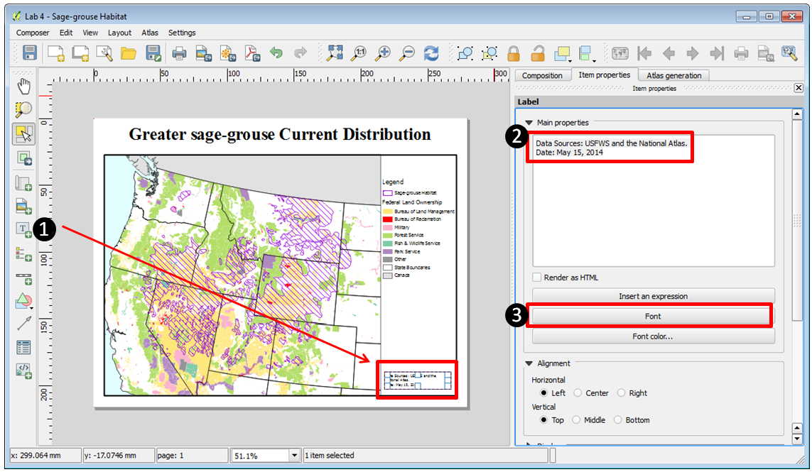

**Figure 35: Adding Supplemental Text**

1. Congratulations your map is finished! The final step is to export it to a high resolution jpg image.
2. **Click** the **Export as image** button 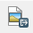.
3. Choose **JPEG** as the **Save as** **type** and save the image to your Lab 4 folder. **Name** the file “*Lab4_Map.jpg*” and click **Save**.
4. The final map should look like **Figure 36**.

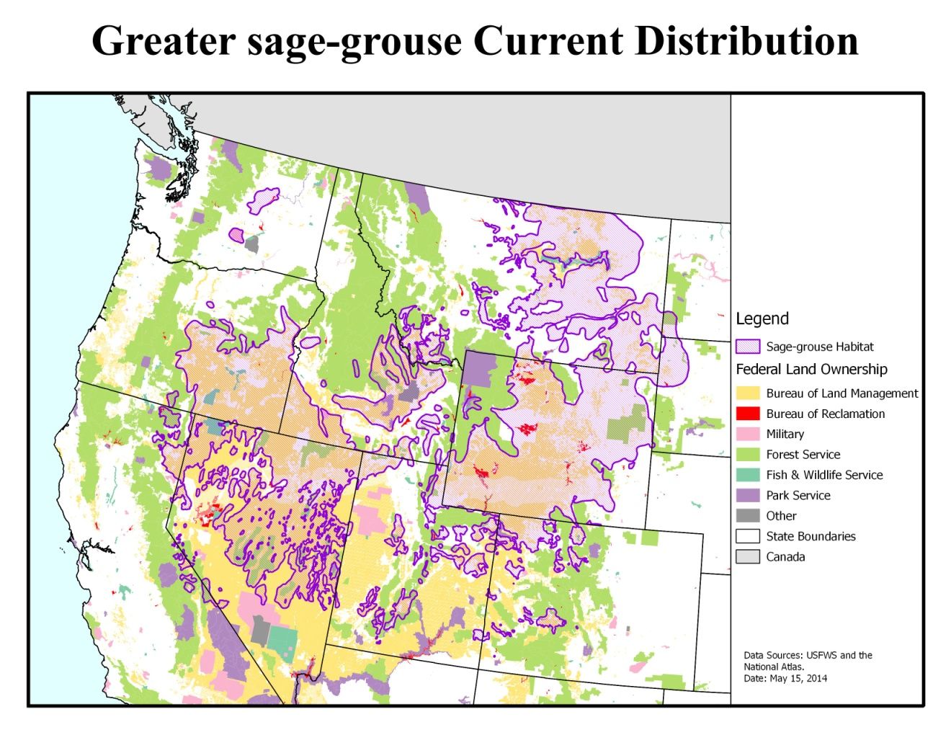 **Figure 36: Final Map**

5 Conclusion

In this lab you’ve created a well-designed map using some of the cartography tools available in QGIS Desktop. You created a nice map highlighting federal land ownership within sage-grouse habitat for a client. This involved styling layers, styling layers by categorical attributes and crafting a map composition.

.

6 Discussion Questions

1. Export the final map as a high resolution jpg for your instructor to grade.
2. What are two ways to add vector data to QGIS Desktop?
3. How would a portrait orientation change the composition of the map? Describe how you would arrange the map elements.
4. No map is perfect. Critique this map. What do you like about it? What do you dislike about it? How would you change this map to improve it? Would you add other data layers or add labels?

7 Challenge Assignment

Another biologist working with black bears on the east coast heard about your great work on the sage-grouse map. She would like you to create a similar map for her. The data she is providing is in the Lab 4/Data/Challenge folder.

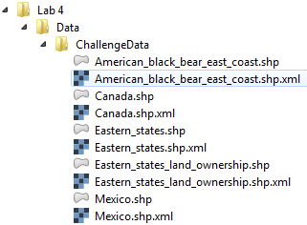

She also needs letter sized, color, map figure but that shows the relationship between black bear habitat and federal land ownership along the eastern seaboard. She is interested in seeing how much habitat is under federal versus non-federal ownership.

She is providing data from the US Fish and Wildlife Service depicted current occupied range for black bear on the east coast. She is also providing federal land ownership, state boundaries and country boundaries from the US National Atlas. The land ownership data has an attribute column describing which federal agency manages the land (AGBUR). This land ownership dataset has another category in the AGBUR field for Wilderness Areas called "Wild". These should be styled with a dark green.

She wants to have the habitat data shown so that the federal land ownership data is visible beneath. She would like each different type of federal land styled with standard Bureau of Land Management colors. The map should also include a title (“Black Bear Current Distribution”), a legend, data sources and the date. The map should be a high-resolution (300 dpi) jpg image. Perhaps you can incorporate some improvements to this map!